ASSESMENT-2


K. R. MANGALAM UNIVERSITY BTech (AI & ML) SOET
(School of Engineering and Technology)

NAME: Anurag Pandey
ROLL NO: 2301730094
COURSE: Computer Networks Course Code: (ENCS352)
K. R. MANGALAM UNIVERSITY, SOHNA ROAD GURUGRAM, HARYANA

Experiment Objectives :

Students will use Packet Tracer Simulation Mode to observe how packets move between devices, how switches learn MAC addresses, and how ICMP echo request/reply travels through a small network.

Learning Outcomes:
• Use Simulation Mode effectively
• Observe ARP + ICMP behavior
• Understand switch MAC learning behavior
• Interpret packet event list timeline

Concepts Used
• Simulation Mode
• ICMP ping
• ARP resolution
• Switch MAC address table learning

Github link : Anurag637/Computer-Network
Task 1: Build a Simple LAN
Step 1: Place Devices
Add the following devices in Packet Tracer:
1 Switch (for example 2960)
3 PCs

Step 2: Connect Devices
Use Copper Straight-Through cables.
Connections example:
- PC1 → Switch (Fa0/1)
- PC2 → Switch (Fa0/2)
- PC3 → Switch (Fa0/3)
Step 3: Assign IP Addresses

Task 2: First Ping Observation
Step 1: Enable Simulation Mode
At the bottom of Packet Tracer, switch from Realtime Mode → Simulation Mode.
Step 2: Start Ping
On PC1 open Command Prompt and type:
ping 192.168.20.2

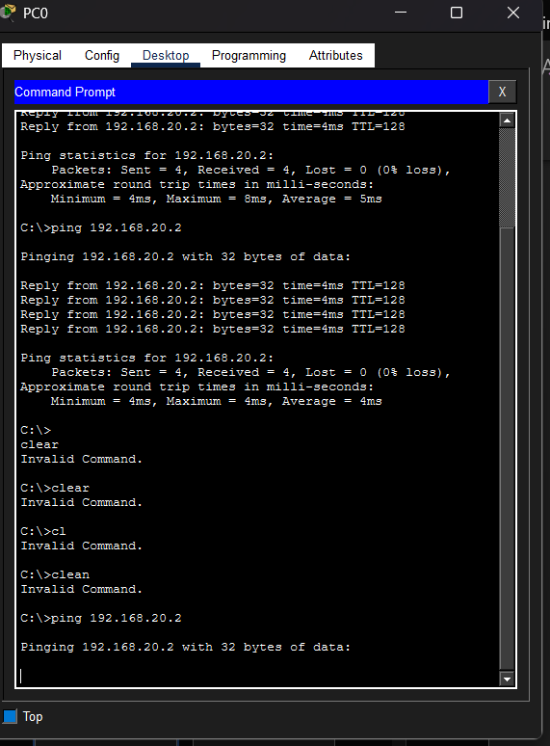
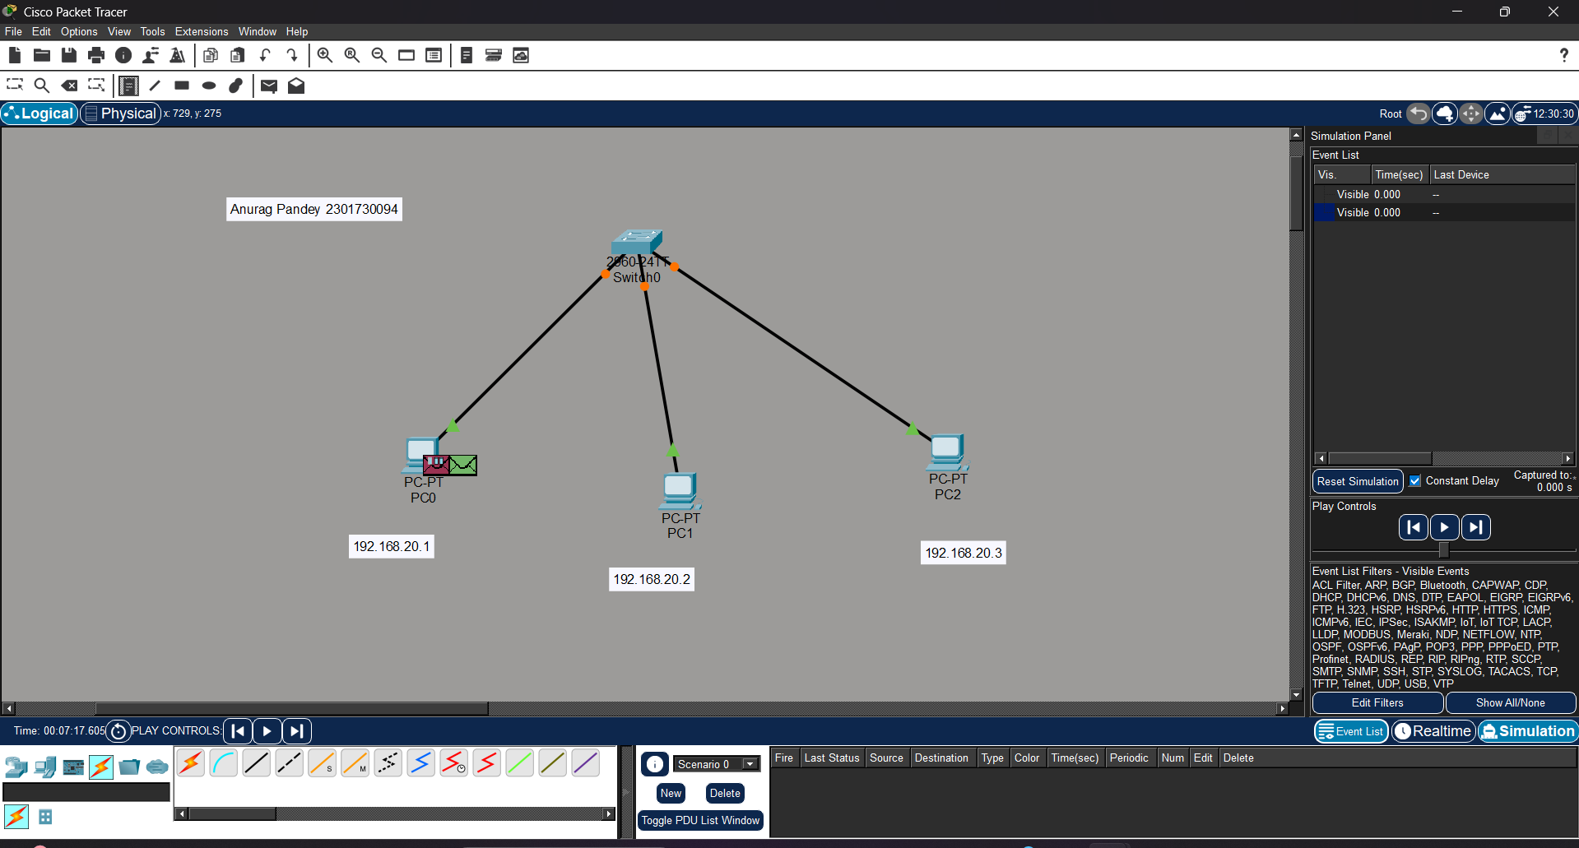

Step 3: Observe Packet Events
You will see the following sequence in the Event List.
Step A: ARP Request
Before sending the ping, PC1 must find the MAC address of PC2.
PC1 sends an ARP Request asking:
Who has IP 192.168.20.2?
This request is broadcast to all devices.
Switch forwards the broadcast to:
- PC2
- PC3

Step B: ARP Reply
PC2 replies with its MAC address.
Example response:
192.168.20.2 is at MAC address XX:XX:XX
Switch forwards this reply only to PC1.

Step C: ICMP Echo Request
After ARP resolution, PC1 sends an ICMP Echo Request to PC2.

Step D: ICMP Echo Reply
PC2 responds with ICMP Echo Reply, confirming successful communication.
This completes the ping process.

Task 3: Second Ping Observation
Run the command again:
ping 192.168.20.2

Observation
This time:
ARP request does not occur
Only ICMP request and reply packets are visible

Reason
The MAC address is already stored in the ARP cache, so PC1 does not need to send ARP again.
This is why the second ping is faster.

Task 4: MAC Table Check (Switch Learning)
Switches learn MAC addresses automatically.
When packets pass through the switch:
The switch records MAC address + port number in its MAC table.
Example MAC Table:
MAC Address | Port
PC1 MAC | Fa0/1
PC2 MAC | Fa0/2
PC3 MAC | Fa0/3
Switch learning happens by checking the source MAC address of incoming frames.
After learning, the switch forwards frames only to the correct port instead of broadcasting.

